ASSIGNMENT 6.5:

Write a Mapreduce code to find out number of males and females survived in the titanic tragedy and save the output in sequence file output format.

Driver Class:

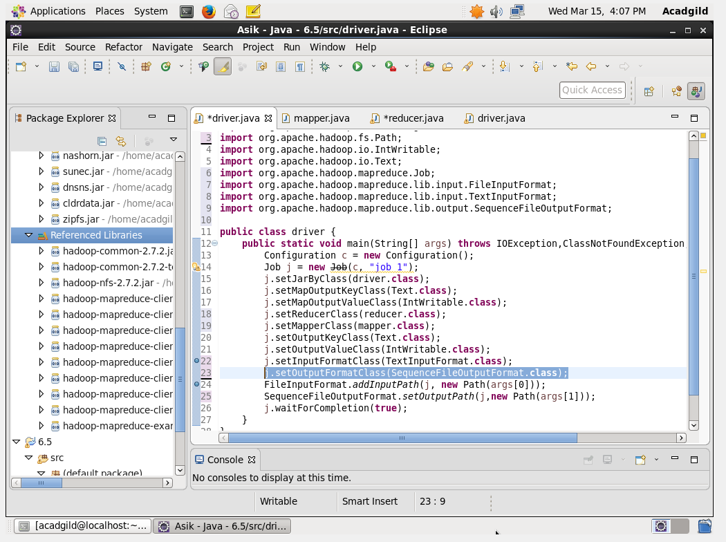

Mapper Class:

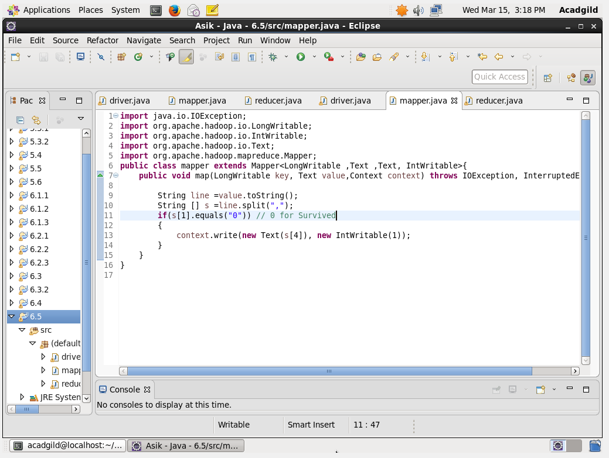

Reducer Class:

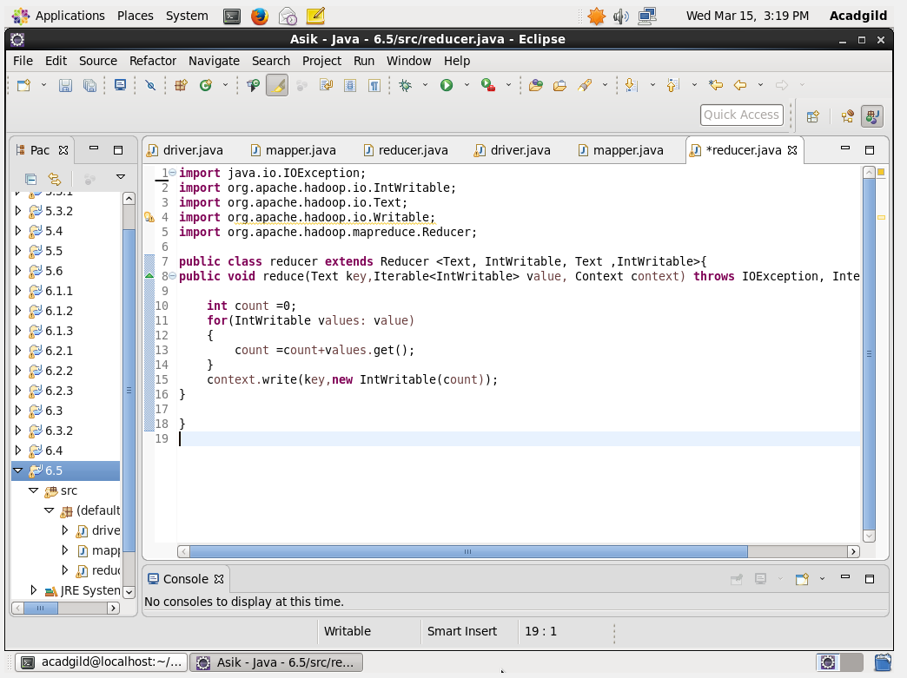

Output:

